

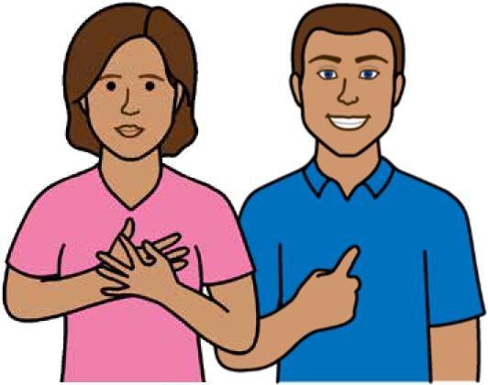

**Self care**



**Easy English**

**Hard words**

|  |  |
| --- | --- |
|  | This book has some hard words. |

The first time we write a hard word

* the word is in **blue**
* we write what the hard word means.

**You can get help with this book**

|  |  |
| --- | --- |
|  | You can get someone to help you   * read this book * know what this book is about * find more information. |
|  |

**About this book**

|  |  |
| --- | --- |
|  | This book is written by the  Department of Health. |

This book is about **self care** for parents.

|  |  |
| --- | --- |
|  | **What is self care?**  Self care means you look after yourself. |

**Sleep**

|  |  |
| --- | --- |
|  | To help you get enough sleep   * go to bed at the same time each night |

|  |  |
| --- | --- |
|  | * make your bedroom a place you can relax * have naps for 20 minutes in the day when   your baby is asleep. |

|  |  |
| --- | --- |
|  | Before bed do **not**   * exercise * use your phone * drink coffee * have naps late in the day.  **Exercise** |

Make a time for exercise once every day.

|  |  |
| --- | --- |
|  | Exercise might mean   * a walk outside with the pram * yoga. |

**Eat healthy food**

Make sure you

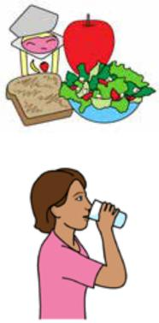

* eat healthy snacks in the day
* drink water when you are thirsty
* make easy meals on busy days. For example, eggs or a toasted sandwich.

**Make friends**

To help you meet new people you can

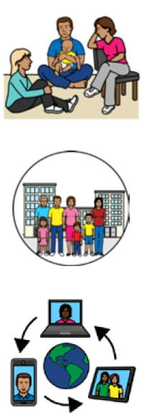

* join a new parent group or play group
* go to events in your local community
* join a group on social media.

**Be nice to yourself**

|  |  |
| --- | --- |
|  | It is normal to feel upset or scared sometimes.  It can help to   * talk to someone you trust * plan things you can do to feel better. |

|  |  |
| --- | --- |
|  | **Talk to your partner**  A new baby can change your relationship with your partner.  It might be hard to get along with your partner. For example, you might   * **not** agree about how to share the jobs and house work |

* worry about how to be a good parent

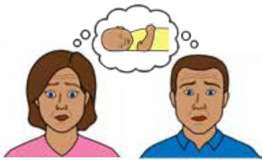

* have less time to do nice things together. Talk to your partner about your problems first.

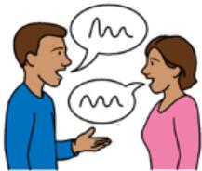

If you are still worried about your relationship you might talk to a **relationship counsellor**.

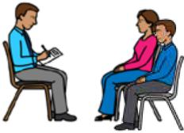

A relationship counsellor is an expert who can

help you and your partner work out problems.

**Why is self care important?**

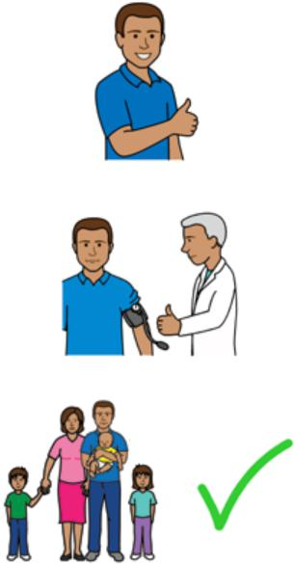

Self care can help you

* feel good
* be healthy
* be a good parent.

|  |  |
| --- | --- |
|  | You can use self care any time.  For example   * when your baby is asleep |

|  |  |
| --- | --- |
|  | * when someone else looks after your baby. |

|  |  |
| --- | --- |
|  | **Your mental health**  There are many changes to your life after you have a baby.  Changes to your mental health are normal.  **Baby blues** |

**Baby blues** means you feel sad after your baby is born. For example

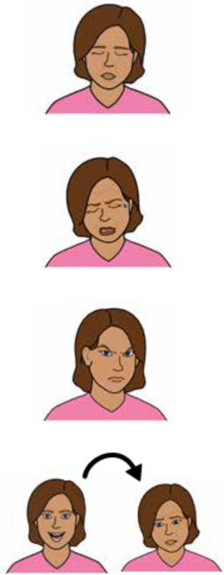

* you feel tired
* you cry a lot
* you are grumpy
* your mood changes often.

|  |  |
| --- | --- |
|  | Baby blues   * are normal * happen in the first few days after you have your baby |

* go away after a few days.

**Postnatal anxiety**

|  |  |
| --- | --- |
|  | **Post natal anxiety** means you   * worry about things most of the time * worry that you might do things wrong all the time * find it hard to sleep. |

You might have **panic attacks**.

Panic attacks might mean

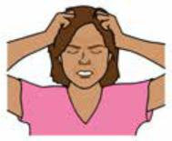

* you feel like things are out of control
* everything feels like it is too much
* your heart beats fast or you might find it

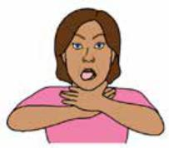

hard to breathe.

**Postnatal depression**

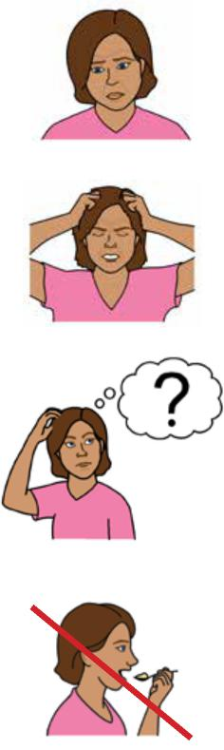

**Postnatal depression** means you

* feel sad most of the time
* can **not** cope with things
* can **not** think straight.

You might find it hard to

* eat

|  |  |
| --- | --- |
|  | * sleep * focus. |

|  |  |
| --- | --- |
|  | Postnatal depression   * can happen in the first year after you have your baby |

* can last 1 - 2 years if you do **not** get help.

**Are mental health problems common?**

1 in 7 mothers get postnatal depression.

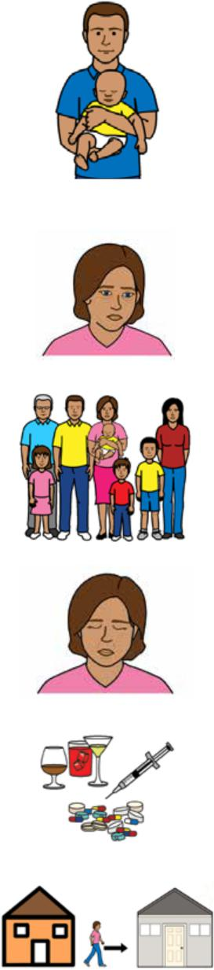

1 in 10 fathers get postnatal depression.

You might be more likely to get postnatal depression if

* you have had depression or anxiety before
* someone in your family has mental health problems
* you feel tired or do **not** get enough support
* you use drugs or alcohol
* there are big changes to your life.

For example, you move house.

**Help for postnatal depression**

|  |  |
| --- | --- |
|  | Postnatal depression happens less if you   * use self care * think about things in a positive way * have people around that care for you * ask for help when you need it. |

|  |  |
| --- | --- |
|  | **It is okay to get help**  There is nothing wrong with asking for help.  You are **not** a bad person if you feel sad after you have a baby.  Lots of people get help for  postnatal depression. |

There is information about safe ways to get help at the end of this book.

|  |  |
| --- | --- |
|  | **Where to get help** |

If you are worried about mental health you can call the Maternal and Child Health Line.

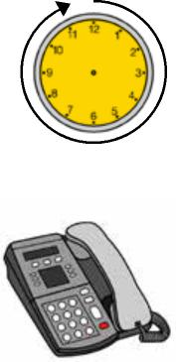

The helpline is open 24 hours per day and 7 days per week.

Call 13 22 29.

You can contact your

* Maternal and Child Health Nurse
* doctor
* counsellor or psychologist.

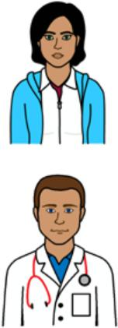

**Beyond Blue**

|  |  |
| --- | --- |
|  | Go to the Beyond Blue website  <https://www.beyondblue.org.au/mental-health/parenting> |
|  |

**Perinatal Anxiety and Depression Australia or PANDA**

|  |  |
| --- | --- |
|  | Call 1300 726 306  The help line is   * free |

|  |  |
| --- | --- |
|  | * open Monday to Friday from 9 am to 7.30 pm. |



Website

[www.panda.org.au](http://www.panda.org.au)

**Centre of Perinatal Excellence or COPE**

Website

[www.cope.org.au/new-parents/postnatal-mental-health-conditions/postnatal-mental-health-factsheets-resources/](http://www.cope.org.au/new-parents/postnatal-mental-health-conditions/postnatal-mental-health-factsheets-resources/)

|  |  |
| --- | --- |
|  | **Help for dads**  Relationship Australia website  [supportforfathers.com.au/resources](http://supportforfathers.com.au/resources) |

|  |  |
| --- | --- |
|  | Raising Children website [raisingchildren.net.au](http://raisingchildren.net.au) |

|  |  |
| --- | --- |
|  | COPE website  [cope.org.au/readytocope](http://cope.org.au/readytocope)  Beyond Blue website.  [www.beyondblue.org.au/About/](http://www.beyondblue.org.au/About/)  **Clinical care**  You can get special help from hospitals for serious mental health problems.  Website  [vahi.vic.gov.au/mental-health-services/](https://vahi.vic.gov.au/mental-health-services) |
|  |

|  |  |
| --- | --- |
|  | **More information**  For more information contact the Department of Health. |

|  |  |
| --- | --- |
|  | Website  [www.betterhealth.vic.gov.au/ healthyliving/Child-health-0-6](https://www.betterhealth.vic.gov.au/healthyliving/Child-health-0-6) |

|  |  |
| --- | --- |
|  | **If you need help to speak or listen**  You can use the National Relay Service or  NRS if you need help to make a call. |

|  |  |
| --- | --- |
|  | Call the NRS help desk  1800 555 660 |

|  |  |
| --- | --- |
|  | Go to the NRS website  [www.accesshub.gov.au/about-the-nrs](http://www.accesshub.gov.au/about-the-nrs ) |

To receive this publication in an accessible format email Maternal and Child Health and Early Parenting: [MCH@health.vic.gov.au](mailto:MCH@health.vic.gov.au).



Authorised and published by the Victorian Government, 1 Treasury Place, Melbourne.

© State of Victoria, Australia, Department of Health, July 2020.

**ISBN** 978-1-76069-222-3

Available at [https://www.betterhealth.vic.gov.au/ healthyliving/Child-health-0-6](https://www.betterhealth.vic.gov.au/healthyliving/Child-health-0-6) (pdf/online).

Certain text, images and information incorporated in this publication were created by Scope (Aust) Ltd at [www.scopeaust.org.au](http://www.scopeaust.org.au) and Tobii Dynavox.

Scope (Aust) Ltd produced this Easy English version with the Department of Health in December 2020. The ‘Easy English’ style of writing is © Scope (Aust) Ltd 2020 (“Clear Written Communications - The Easy English Style Guide”). All Rights Reserved Worldwide. To contact Scope about its Easy English style of writing and its services call 1300 472 673 or visit [www.scopeaust.org.au](http://www.scopeaust.org.au)

The following materials contained in this document are not licensed to the State of Victoria, Australia,

Department of Health (‘excluded materials’):

- The Picture Communication Symbols ©1981–2020 by Tobii Dynavox. All Rights Reserved Worldwide. Used

with permission. BoardmakerTM is a trademark of Tobii Dynavox.

- Certain other images and photographs (as marked).

Permission must be obtained from Tobii Dynavox or any other relevant third parties (as applicable) to use, copy,

reproduce, digitise, adapt, modify, communicate or publish any part of the above excluded materials.