

Victorian Patient Transport Assistance Scheme (VPTAS)
How to submit a VPTAS claim online - A step-by-step guide for claimants
OFFICIAL

About this guide

This guide explains how to submit a Victorian Patient Transport Assistance Scheme (VPTAS) claim online through the Victorian Concessions and Allowances service in myGov.

It explains how to:

sign in through myGov

link the Victorian Concessions and Allowances service

set up your profile

nominate a patient

submit a VPTAS claim

upload supporting documents

track your claim

Before you start

VPTAS helps eligible Victorians with the cost of travel and accommodation when they need to travel long distances for specialist medical or some specialist dental treatment.

VPTAS is a subsidy scheme. It does not cover all costs.

You may be eligible if you:

are an Australian citizen, permanent resident or refugee

are a Victorian resident at the time of referral and treatment

travel to the closest eligible medical or dental specialist service

need to travel 100 km one way, or 500 km within 7 days, for the specialist service

lodge your claim within 12 months of your specialist appointment.

For full eligibility details, refer to the VPTAS Guidelines 2026.
What you need before you apply
Before you start your online claim, have ready:
- your myGov sign-in details
- your completed Specialist Confirmation Form
- your treatment, travel and accommodation details
- receipts or invoices, where required
- your bank account details
- your concession card details, if applicable
- your completed Flight Confirmation Form, if you are claiming flights.

Appointment notifications or booking confirmations cannot be used instead of the Specialist Confirmation Form.
Receipts are not required for private or rental car travel, or for Public Transport Victoria services such as V/Line or myki. Other travel and accommodation claims need receipts or invoices.
⚠️ Important Claims must be submitted within 12 months of attending your approved specialist service.

Access the online service
VPTAS online claims are submitted through the Victorian Concessions and Allowances service in myGov.

- Create or sign in to myGov at my.gov.au.
- Link the Victorian Concessions and Allowances service if it is not already connected.
- Select the Victorian Concessions and Allowances service from your myGov homepage.

You can find instructions to link the service on the myGov website <https://my.gov.au/en/about/help/mygov-website/link-services-to-your-account/link-victorian-concessions-and-allowances>.

If you received a one-time code from VPTAS

If you have received a one-time code from VPTAS, use it the first time you access the Victorian Concessions and Allowances service in myGov.

This helps connect your existing VPTAS information.

If you did not receive a one-time code, you can still use the service and set up your profile.
Navigating the online service
These buttons are used throughout the online service:
Exit | Leaves the application. If you have made changes, you may be asked whether you want to save or leave without saving.
Next | Saves your entries and moves you to the next step.
Back | Takes you back to the previous step.
Save | Saves the details entered in the current section.
Submit | Lodges your completed claim with VPTAS.

✅ Tip Save your information before moving to another section or leaving the application.

1 | Open the portal and select 'Start VPTAS Application'

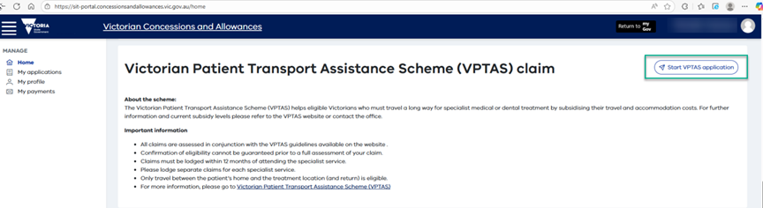

Overview: three steps to submit a claim
To submit a VPTAS claim online, complete these three steps:
- Tell Me About Yourself: set up your profile.
- Nominate Patient: add the person travelling for treatment.
- Start Application: submit your VPTAS claim
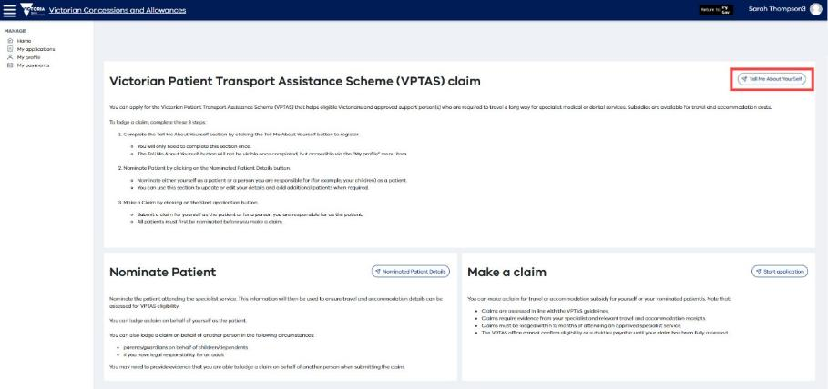

✅ Tip You only need to complete Tell Me About Yourself once. For future claims, you can go straight to Nominate Patient and Start Application.

Step 1: Tell Me About Yourself: set up your profile
The first time you use the online service, select Tell Me About Yourself to set up your profile.

You only need to do this once. After your profile is set up, the Tell Me About Yourself button will no longer appear.

2 | Click 'Tell Me About Yourself' to enter your applicant details

You can update your details later through the My Profile menu.

Complete all relevant sections of the form.

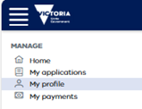

✅ Tip: Mandatory fields are marked with an asterisk (*). You must complete all mandatory fields, including your email address and mobile phone number, to continue.

Your applicant details
Enter the following details about yourself (the applicant):
- Given name
- Surname
- Email address
- Mobile phone number
- Other phone number (if applicable)
- Date of birth

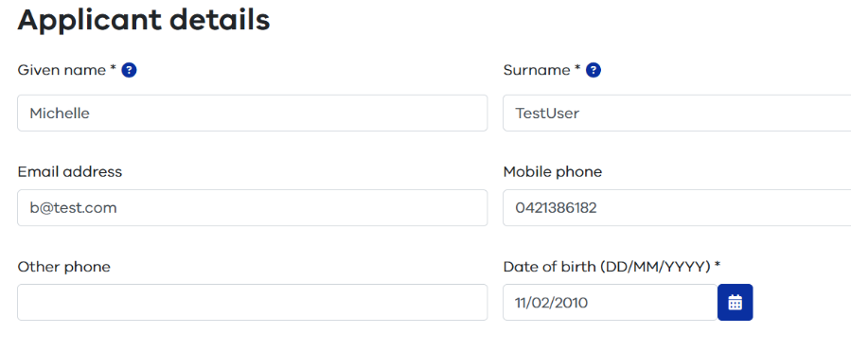

Your address
Type your address into the Current residential address field. The form will suggest matching addresses — select the correct one from the list.

⚠️ Important Some rural addresses may need to be entered manually. If you cannot find your address, tick the 'Enter address manually' checkbox.

If your postal address is different to your residential address, tick 'Add new postal address' and enter the details. Otherwise, select 'Same as above'.

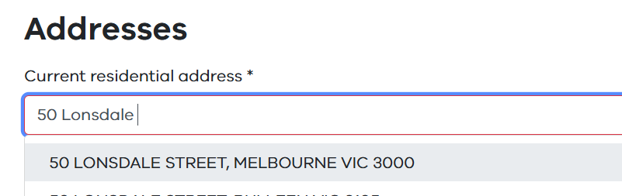

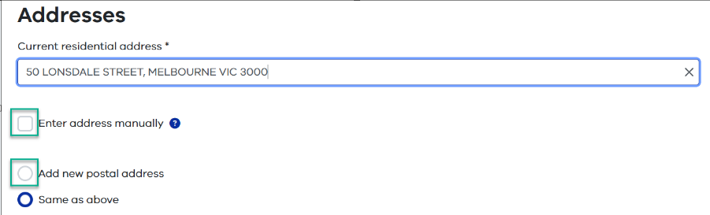
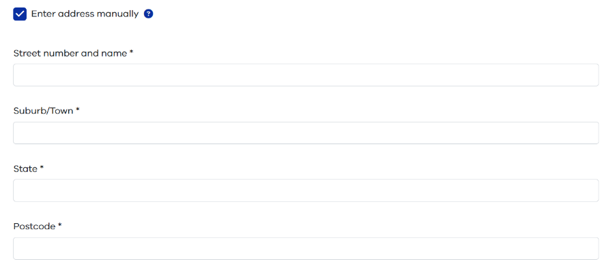

Your bank account details
Enter the bank account details (BSB and account number) for where any approved VPTAS subsidy payment should be paid.

Check these details carefully before you continue.

⚠️ Important The Account number field requires a minimum of six digits. If your account number has fewer than six digits (for example, a passbook account), add zeros to the beginning. For example, enter 001234 instead of 1234.

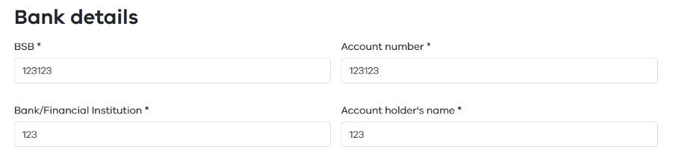

Concession card details (optional)
If you hold a Centrelink concession card or a Blue or white Department of Veterans’ Affairs card, enter the details in this section.

- Cards starting with a number and ending with a letter are Centrelink concession cards.
- Cards starting with a V are Veterans' Affairs cards.

If you leave this section blank, a contribution payment may apply to your claim. If you enter a card number, you will be asked to provide consent, your full name, and the type of card.

⚠️ Important The information you enter here affects whether a contribution payment applies. Make sure your card details are correct.

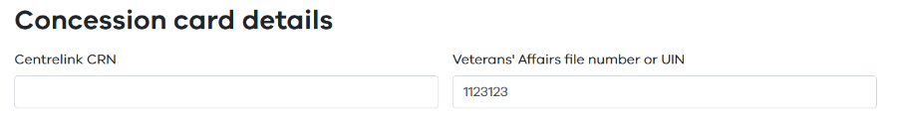
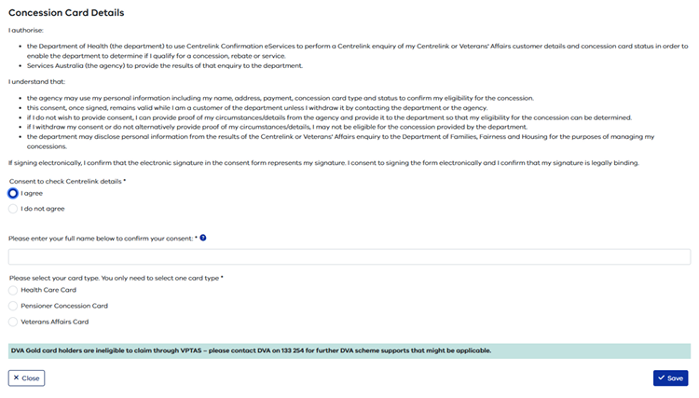
When all details are correct, select Save on the Details screen. A confirmation message will appear to confirm your profile has been saved.

Step 2: Nominate the patient
Before you submit a claim, you need to nominate the patient.
The patient is the person who travelled for specialist treatment.
This may be:
- you
- a child or dependent
- another person you are legally responsible for.

A VPTAS claim can be submitted by:

- the patient
- a parent or guardian of a child or dependent
- a legal guardian of an adult.

If you are applying on behalf of another person, you may be asked to provide evidence of your legal relationship.

If you are the patient
1 | Select 'I am the patient' at the top of the Nominated Patient screen

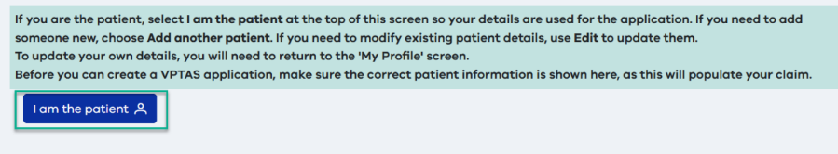

Your name will appear in the list. Select Save to record your nomination.

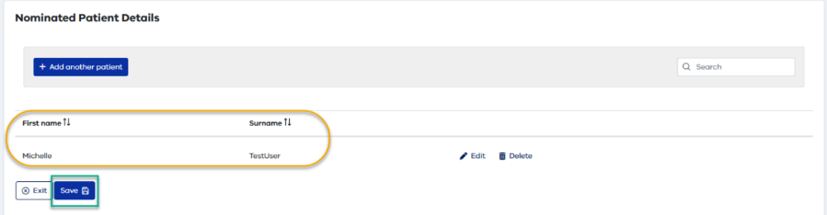

✅ Tip To update your own details, go to the My Profile menu. Changes made there will carry through to your applications.

If you are claiming for someone else
2 | Select 'Add another patient' and enter their details

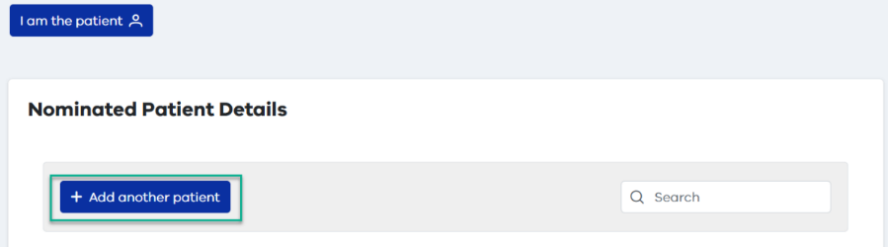

Enter the following information for the nominated patient:
- First name
- Surname
- Date of birth
- Gender
- Email address
- Mobile number
- Indigenous status
- Residential address
- Relationship to the patient (for example, parent or carer)
- Concession card details (if applicable)
If the patient is a child, you may use the parent’s email address and mobile number. You will be asked similar questions about the nominated patient. The patient’s address will default to the parent’s but is not auto-filled to allow for shared care arrangements, so check and enter it correctly.

On the Relationship screen, specify how you are related to the patient (e.g. parent, legal guardian). If you are the legal guardian, indicate this. You do not need to enter a CRN for a child under 18.
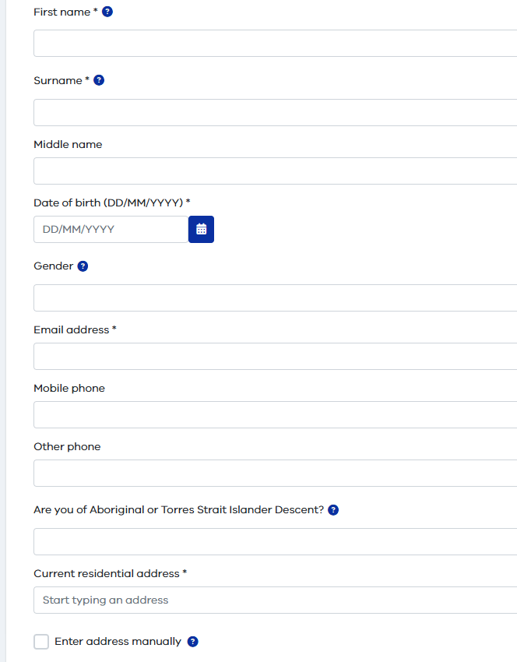

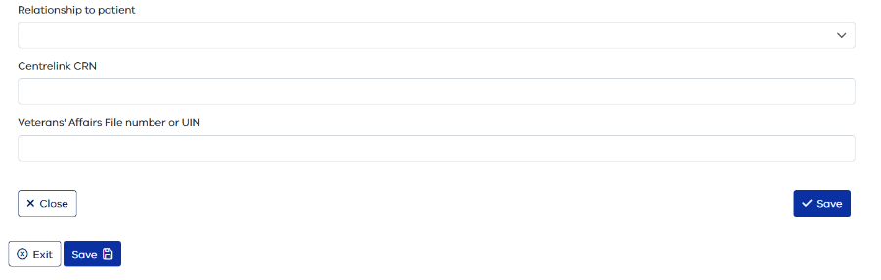

⚠️ Important Gender and Indigenous status are not marked as mandatory, but you must complete them to progress the application.
Note: A claim can be submitted by the patient, a parent or guardian of a child or dependent, or a legal guardian of an adult.

To add a patient, you must save twice:

- Select Save within the patient form.
- Select Save again at the bottom of the page to confirm the patient has been added.
Once the patient appears in the patient list, you can start a claim for that patient.

Editing patient details
To update a nominated patient's details, return to the portal homepage, select Start VPTAS Application, then select Nominated Patient Details.

Click the pencil icon next to the patient's name to edit their details.

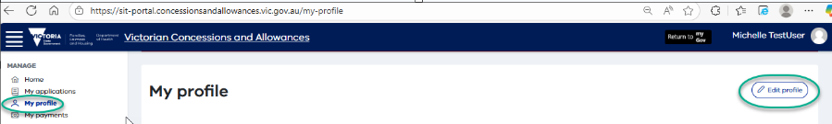
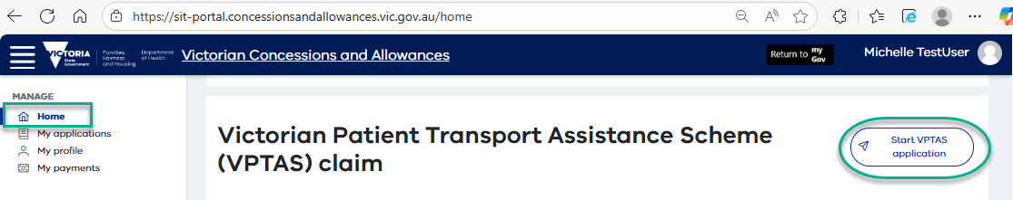
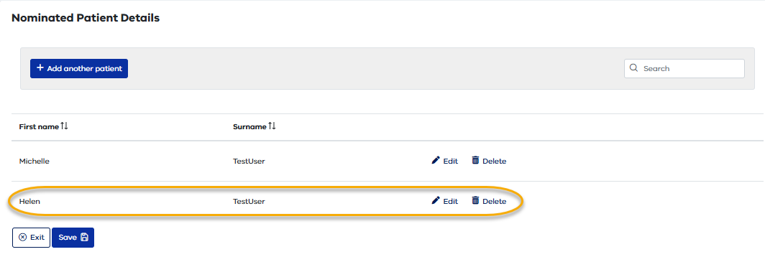

Step 3: Start your VPTAS claim
Once your profile is set up and the patient has been nominated, you can start a claim.
Select Start Application to begin a new VPTAS claim.
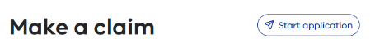

⚠️ Important Submit a separate application for each visit to your specialist. Do not combine multiple visits into a single application.

Complete the Pre-Application Questionnaire
Before you can submit a claim, you must complete the Pre-Application Questionnaire. This helps check whether your claim is likely to meet VPTAS requirements.

Tick all the checkboxes in the questionnaire and then click Next.
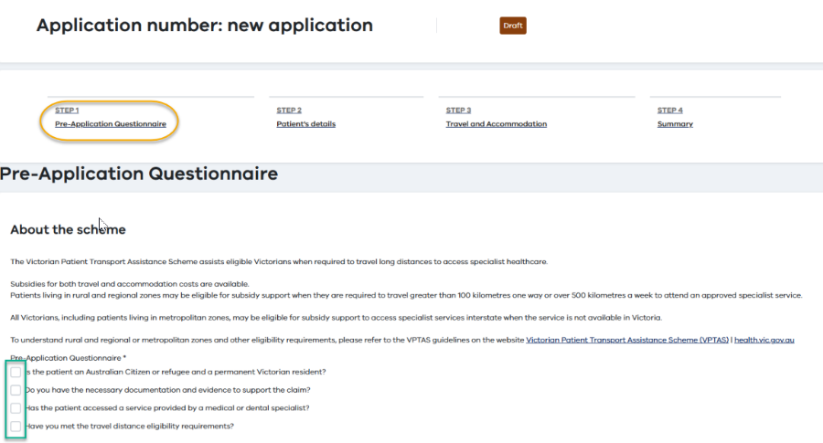

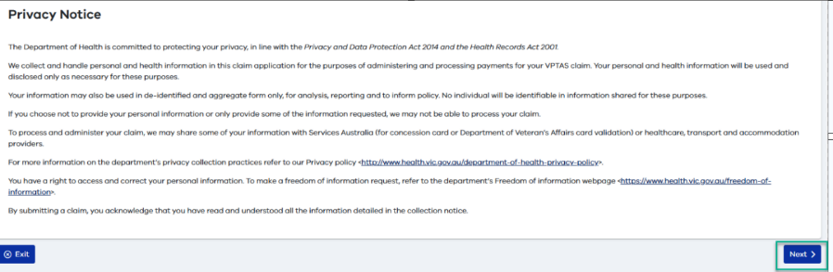

⚠️ Important If you cannot answer Yes to all questions, you may not be eligible for VPTAS. The portal will let you know if you are not able to proceed.

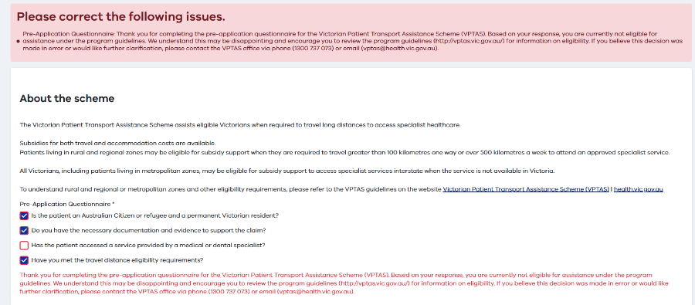

Patient details (Step 2 of the application)
Use the drop-down menu to select the patient for this claim.
- Select I am the patient if you are claiming for yourself.
- Or select the name of another nominated patient you are claiming for.

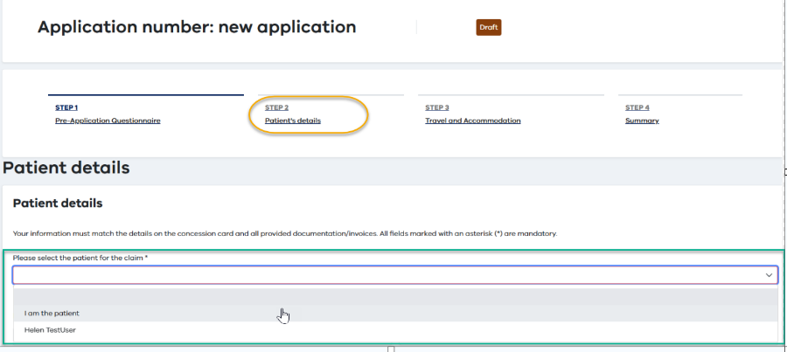

The patient's details will fill in automatically.
Check the details carefully, especially:

- residential address
- bank account details
- concession card details, if applicable.

If you make changes in this section, select Save.
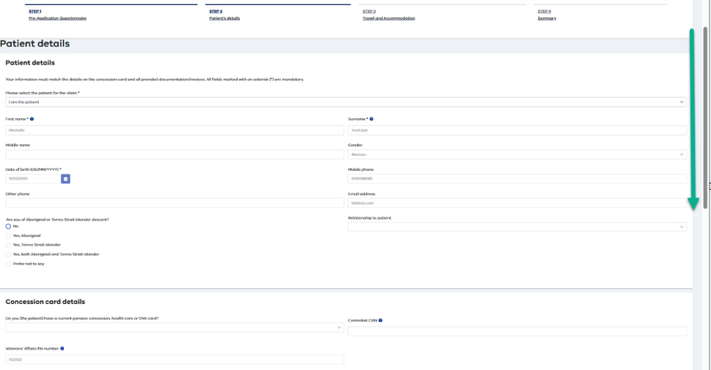

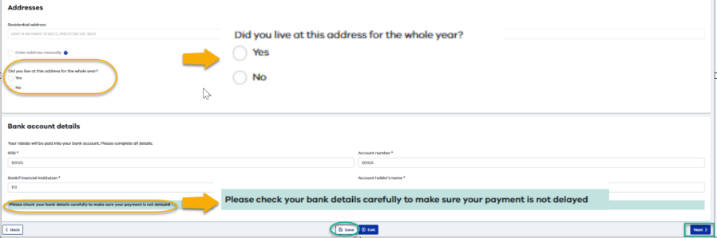

✅ Tip You can edit patient details in this section. Select Save to record any changes. Note that changes here will not update the patient's saved profile.

When you have checked the details, select Next at the bottom of the page.

Travel and accommodation details (Step 3 of the application)

Specialist details
Complete the Approved Specialist Service section with the following:

- Specialist Provider ID — shown on your invoice or attendance certificate
- Specialist name — as it appears on the invoice or referral
- Specialist type — choose from the drop-down list or enter manually

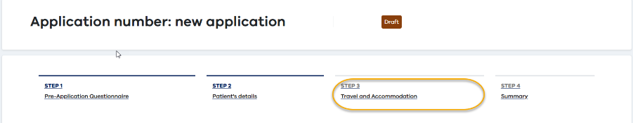

⚠️ Important Upload a valid Specialist Confirmation Form completed by your specialist or their authorised officer. Appointment notifications or booking confirmations cannot be accepted for your claim. If you are claiming accommodation, the number of nights must match the number confirmed on your Specialist Confirmation Form.

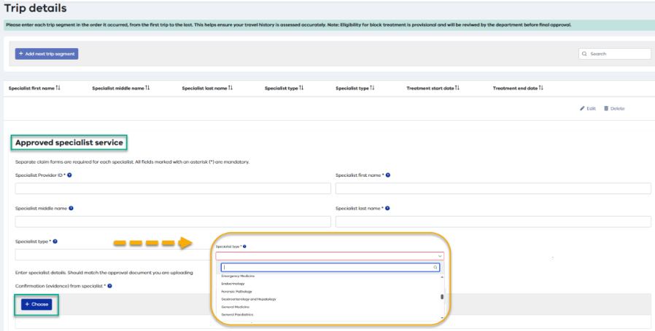

Treatment location
Enter the address where you received specialist treatment and select it from the drop-down list. If the address cannot be found, you can enter it manually.
✅ Tip If using a Hospital or Building Name Tick the box next to ‘Include building name in address search results’

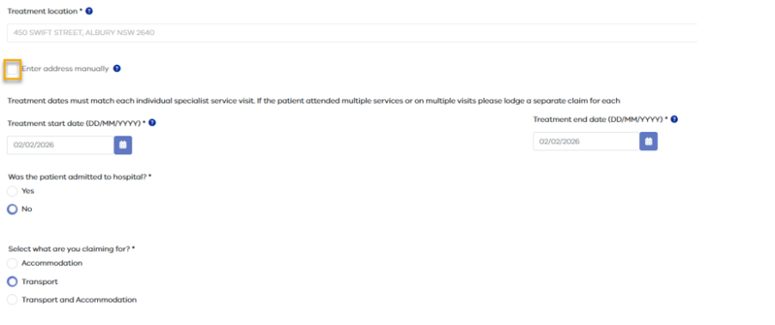

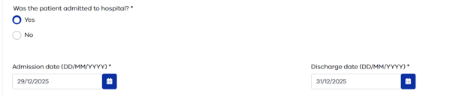

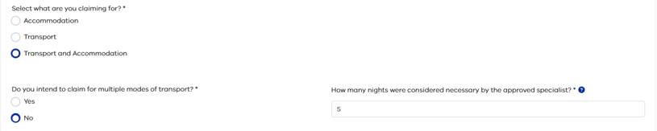

Treatment dates
Enter the dates using the format DD/MM/YYYY.
- Start date — the date you first attended the specialist for this trip
- End date — the last date you attended for this trip

If you attended on a single day, enter the same date in both fields.

⚠️ Important If your specialist admitted you to hospital, tick Yes when asked about hospital admission and enter the admission and discharge dates.

Claim type
Select the type of claim:
- Accommodation — if you are only claiming for overnight accommodation
- Transport — if you are only claiming for travel costs
- Transport and Accommodation — if you are claiming for both

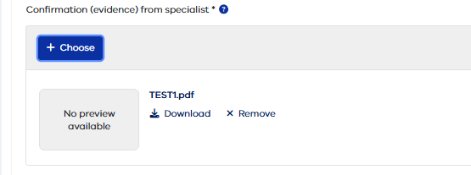

✅ Tip If you selected Accommodation or Transport and Accommodation, a field will appear for you to enter the number of nights accommodation needed.

Payment
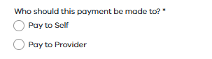
Payment can be made to you or directly to a travel or accommodation organisation on your behalf.
Note: Payments to other providers can be for both travel and accommodation.

Block treatment (multiple short trips)
If the distance between your home and the treatment location is less than 100 kilometres, the portal will ask:

"Are you intending to claim for multiple trips that are less than 100km in distance but would average out to 500km a week for one or more weeks?"

If Yes, select the applicable treatment dates on the calendar (or type them into the field separated by commas). Use the format DD/MM/YYYY.

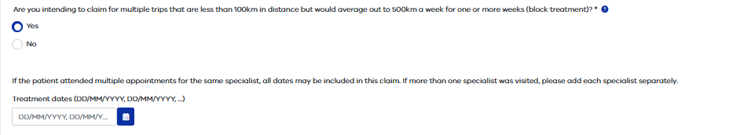
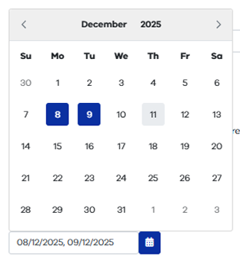

⚠️ Important If you select No and your travel is under 100 kilometres one way, your claim will not meet the distance eligibility requirement. Make sure both your home address and treatment address are correct.

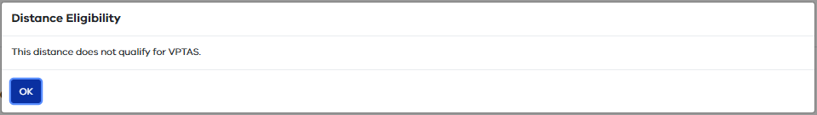

Multiple modes of transport
If you used more than one type of transport to get to your appointment (for example, a combination of private car and plane, or multiple bus services), select Yes when asked about multiple modes of transport.

Additional fields will appear for each leg of the trip. For each leg, enter:
- The start and end location for that leg of the trip
- The type of transport used
- The claimant and payee details

Select Save after each leg. To add more legs, use the Add Next Trip Segment button and repeat the steps.

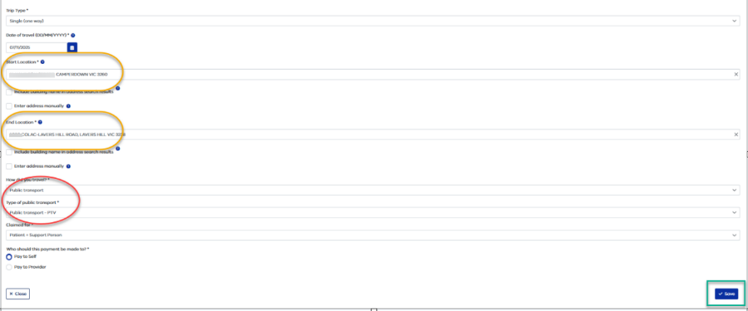
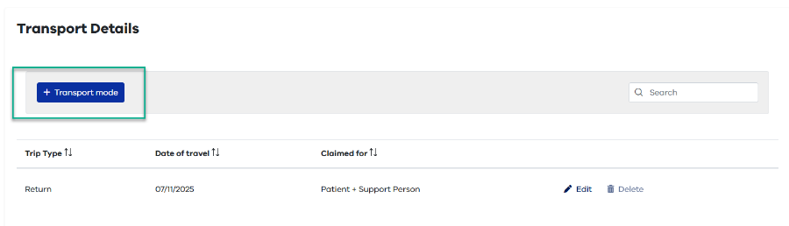
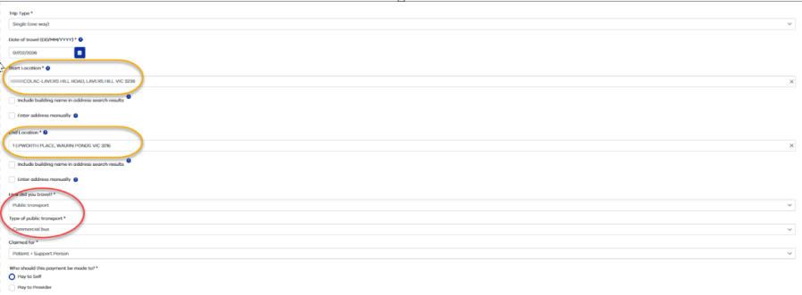

Upload supporting documents
You must upload documents to support your claim. This includes:
- Tax Invoice for accommodation
- Tax Invoice for travel costs (such as flights, taxis, or public transport)

Private car travel does not require receipts.

To upload a document, select Choose, Browse, or drag the file into the upload area. The file details will display when the upload is successful. Select Save.

⚠️ Important After you upload a file, the invoice fields will reset to empty. This is normal — the file has been saved.

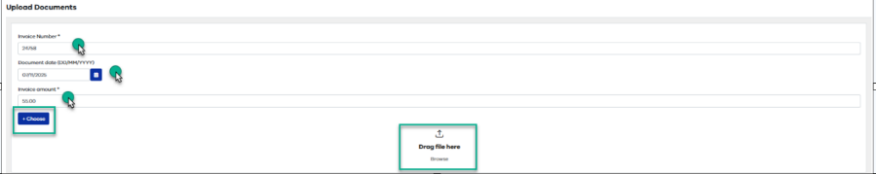

Support person details and declaration
A support person is someone who helps the patient when travelling to and from treatment.

A support person may also be eligible for travel and accommodation subsidy support.

For patients over 18, the treating specialist must confirm the need for a support person.

If a support person travelled with the patient and you are claiming a subsidy for them, enter their details in the support person section.

Complete the declaration checkboxes, then select Save and Next.
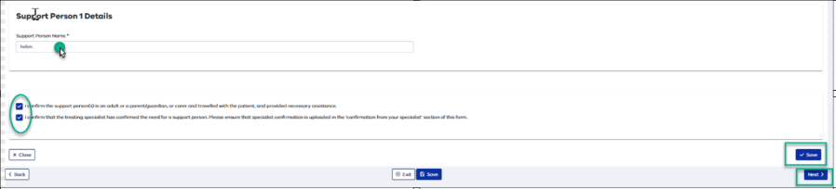

Final review and submission
Review all sections carefully. If you need to go back and change anything, use the Edit Previous Section button.

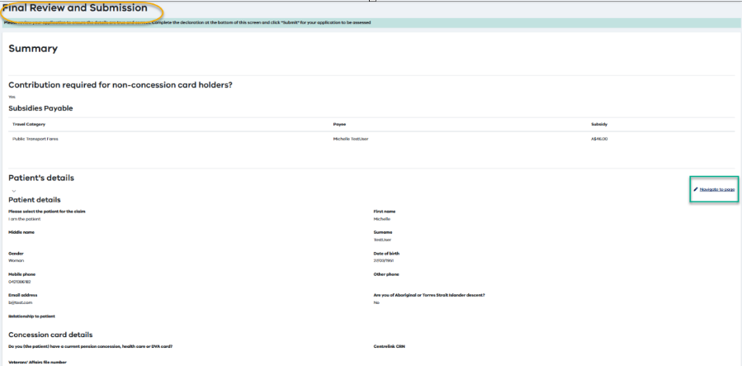

When you are ready, complete the Declaration at the bottom of the page:
- Enter the applicant's details
- Tick the declaration checkboxes

Select Submit to lodge your application.

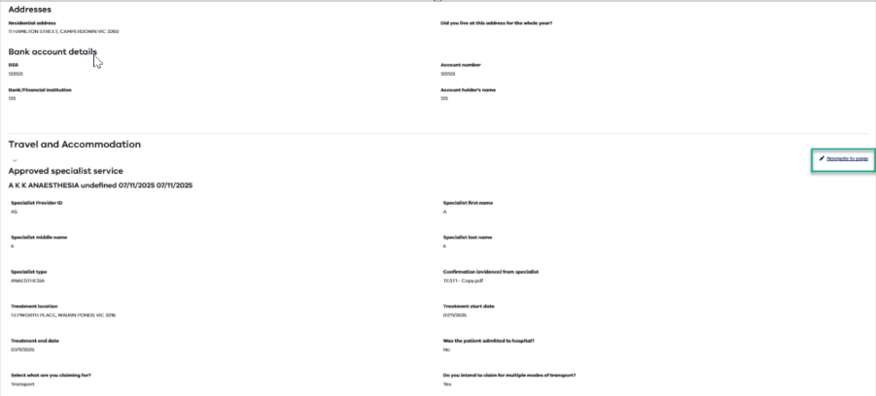

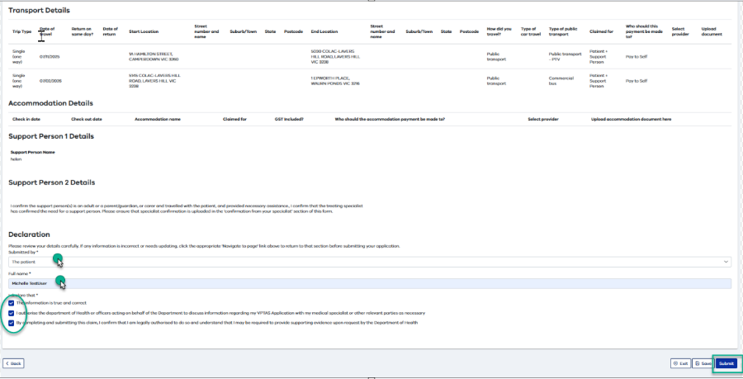

✅ Tip If you're not ready to submit, select Save and then Exit to keep your application as a draft. You can return to it later.

Confirmation of submission
After you submit your application, a confirmation message will appear. Select OK to proceed.
You will also receive a claim received email with your application number.

Keep this email for your records.

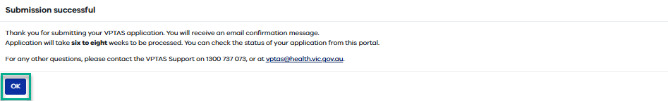
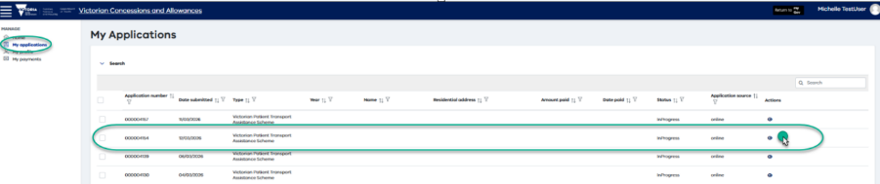

Checking your application status
You can check the status of your application at any time through the portal.

1 | Sign in to myGov and open the Victorian Concessions and Allowances service

2 | Select 'My Applications'

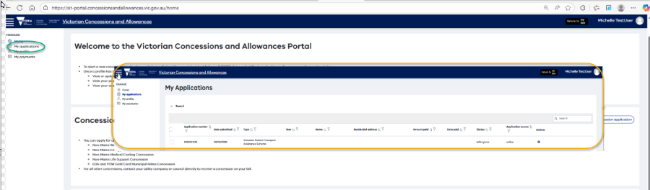

Your applications are listed in the table, with the most recent at the top.
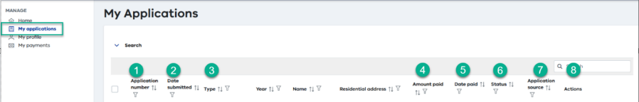

Select the eye icon on the right to view the full details of any application.

Application status guide
Here is what each status means:

Status | What it means
Draft | You've started your application and saved it, but haven't submitted it yet.
In Progress | Your application has been submitted and is waiting to be reviewed.
On Hold | More information may be needed. You may be contacted by the VPTAS team.
Accepted | Your application has been reviewed and approved for payment.
Accepted with Adjustment | Your application was approved, but some changes were made before payment.
Completed | Your application has been fully processed and an outcome has been recorded.
Rejected | Your application was not approved. You may be able to lodge a complaint or appeal.
Invalid Document | The documents you uploaded don't match the details in your application.
Partial Payment | Only part of your claim has been approved for payment.
Ineligible | Your application does not meet the VPTAS eligibility criteria.

Draft and submitted applications
A draft application (started but not submitted) can be:
- Resumed — click the pencil icon
- Deleted — click the bin icon

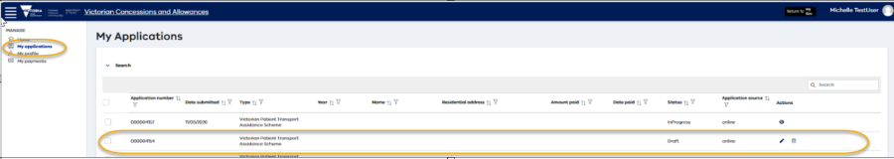

A submitted application can be viewed by clicking the eye icon.
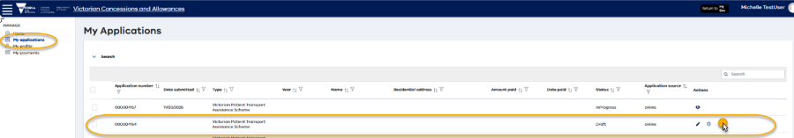

If more information is needed
If VPTAS needs more information, you may receive an email.
The email will explain what information is needed and what to do next.
You can also check your claim status in My Applications.

If you disagree with an outcome
If you disagree with the outcome of your claim, you can ask for an appeal in writing within 3 months of being notified of the outcome.
Include any extra information or evidence to support your request.
Contact VPTAS if you need help.

Do not submit the same claim twice
If you have already submitted a VPTAS claim by email or post and it has not been processed, do not submit the same claim again online.
If you are unsure whether your claim has already been received, contact VPTAS before lodging a new claim.

VPTAS claim and subsidy emails
Not all claims result in a subsidy. You will only receive subsidy payment emails if your claim is approved and a payment is made.

Claim received email
When your claim is approved and a payment is made, you will receive two separate emails about your payment.
These emails may arrive at different times and may arrive in a different order. This is normal.

- Remittance advice (subsidy confirmation)
This confirms that a subsidy payment has been issued.
It shows the payment amount. Your bank may take extra time to show the payment in your account.
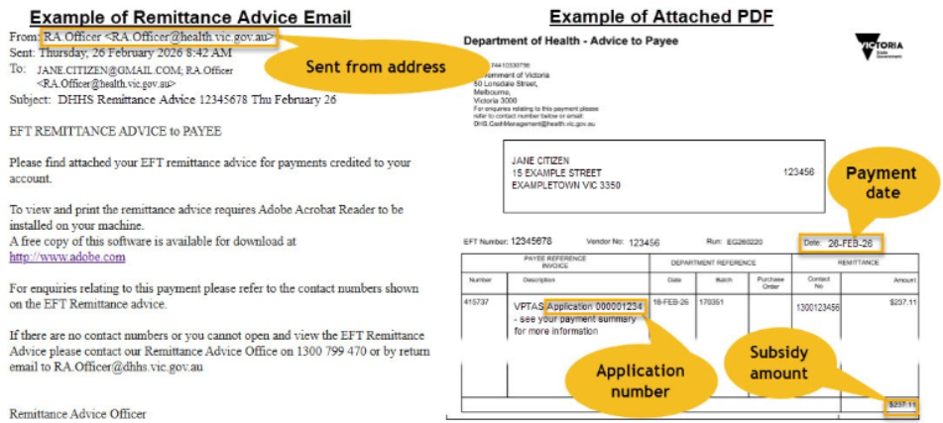

- Payment summary (subsidy details)
This explains what the subsidy payment is for.
It includes the items and dates covered by your claim.
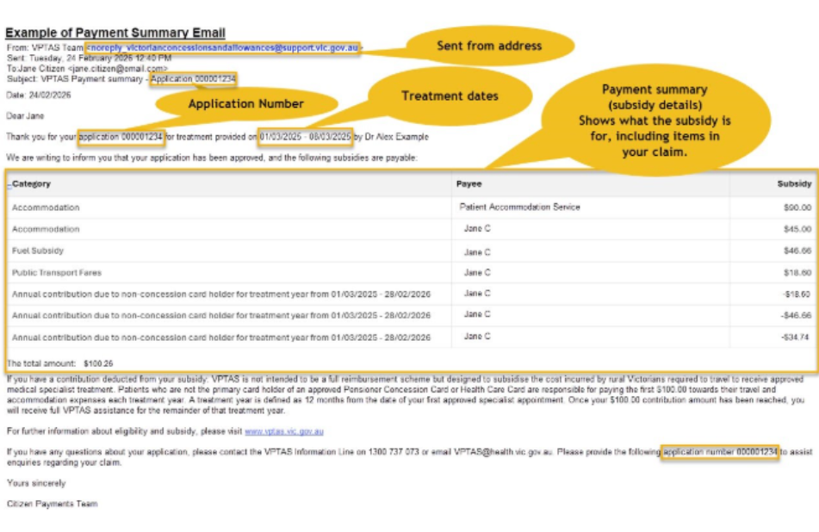
Your application number will be included in the payment summary email when an outcome has been determined.
If you submit your claim online through the Victorian Concessions and Allowances service in myGov, your application number will also appear in the service once your claim has been lodged.

Timing
The remittance advice and payment summary may arrive a few hours apart.
They may also arrive in either order. This is normal.
Your bank may take extra time to show the subsidy payment in your account.

If you only receive one payment email
If you receive a remittance advice but cannot find your payment summary:
- wait a few hours
- check your junk or spam folder
- look for an email from VPTAS Team
If you receive a payment summary but cannot find your remittance advice:
- wait a few hours
- check your junk or spam folder
- look for an email from RA.Officer

Email and scam safety
Check your junk or spam folder regularly so you do not miss VPTAS updates.
Add VPTAS sender addresses to your safe senders or trusted contacts.
VPTAS will never ask for your myGov password, bank login details or personal financial information by email.
If you are unsure whether an email is genuine, do not click on any links. Contact VPTAS first.
Need help?
Phone: 1300 737 073 (business hours)
Email: vptas@health.vic.gov.au
Quote your application number if you have it.

To receive this publication in an accessible format, email the Victorian Patient Transport Assistance Scheme<vptas@health.vic.gov.au>
Authorised and published by the Victorian Government, 1 Treasury Place, Melbourne. © State of Victoria, Department of Health May 2022.
Available at Victorian Patient Transport Assistance Scheme <https://www.betterhealth.vic.gov.au/services-and-supports/victorian-patient-transport-assistance-scheme>

