

Sexual Health Month Communications Toolkit
Sexual Health Month
OFFICIAL

The campaign aims to get people to look after their sexual health as seriously as they would any other aspect of their health.
This toolkit is intended for partners and stakeholders promoting Sexual Health Month through local communication channels. It provides key messages, calls to action and suggested social media copy that can be adapted for local audiences while maintaining consistent campaign messaging.
The aim of this communications toolkit is to promote that sexual health is more than just sex and testing. Sexual health includes prevention (contraception, condoms, PrEP, vaccination), affirmative consent, respectful relationships, communication, pleasure, diversity, sexuality and intersectionality as well as sexually transmissible infections (STI) testing and treatment (if necessary). Talking openly about sexual health with partner(s), friends, doctors, nurses, health workers or anyone else you feel comfortable talking to is important.

Call to Action
A sexual health check is an opportunity to talk openly and confidentially about sexuality, relationships, prevention, protection and STI. A sexual health check is also the only way to know for sure if you have an STI. If you’re sexually active, get a sexual health check at least once a year.

Key messages

Primary
- There’s a lot more to sexual health than just sex! It’s about whether you feel safe and comfortable too. Communication is key before, during and after sex.
- Talk openly with your partner(s) about sexual health, pleasure, consent and protection.
- The 4 Cs of Safer Sex
  - Communication – Talk openly with your partner(s) about sexual health and pleasure.
  - Consent <https://www.premier.vic.gov.au/affirmative-consent-model-now-law-victoria> – Take steps to check that everyone involved is freely agreeing to each sexual activity.
  - Contraception <https://www.betterhealth.vic.gov.au/health/healthyliving/contraception-choices> – Take steps to avoid an unintended pregnancy.
  - Condoms <https://www.betterhealth.vic.gov.au/health/healthyliving/contraception-condoms-for-men> – Use protection to reduce the risk of STIs and unintended pregnancy.
- If you’re having sex, you should get a sexual health check including STI testing at least once a year. All STI testing should include chlamydia, gonorrhoea, HIV and syphilis testing. 1 in 6 Australians will get an STI in their lifetime.
- STIs don’t discriminate by age, location, gender, sexuality or lifestyle. Anyone who has sex can get an STI – even if you practice safer sex most of the time.
- All STIs are treatable and most are curable. The key is early detection and treatment.
- Tests can vary depending on your needs, but may include a urine sample, blood test or swab. Some tests can also be self-collected. Be proud of your choice to get checked and look after yourself.
- STI tests are affordable, confidential, and free at bulk billing GP’s, sexual health clinics and some online telehealth services.

Secondary
- Anyone who is having sex should get a sexual health check. It’s that simple.
- If left untreated, STIs can have serious long-term effects on your body and reproductive health.
- If you are pregnant or planning a family, it is important that you and your partner have a sexual health check (including STI testing) to prevent any infections being passed onto your baby.
- It is important to let your sexual partner(s) know that you have an STI so that they can be tested and treated, which can help prevent you from getting reinfected.

Call to action
- Visit your GP, Sexual Health clinic, community health centre Stay STI Free <https://www.staystifree.org.au/> or 1800 My Options <https://www.1800myoptions.org.au/>
- Information is available on the Better Health Channel <www.betterhealth.vic.gov.au/your-sexual-health>
- You can let your partners know anonymously and confidentially through Let them Know <https://letthemknow.org.au/> or The Drama Downunder. <https://www.thedramadownunder.info/let-them-know/> Your local doctor or health service can also help you do this.

Communication assets
A complete suite of Sexual Health Month print and digital assets is available <http://www.betterhealth.vic.gov.au/your-sexual-health>
On this webpage you will find:
- Social media tiles
- Digital assets
  - Email banners
  - Teams backgrounds
  - Website banners
- Sexual health month factsheet in English and the following languages:
  - Arabic
  - Chinese (Simplified)
  - Filipino
  - Malay
  - Punjabi
  - Spanish
  - Thai
  - Vietnamese

Suggested social post copy
Below are prepared social media captions that can be used across your social media platforms. All the tiles are available online <www.betterhealth.vic.gov.au/your-sexual-health>

Suggested text | Channel | Tile
Talk and check before you the fun begins!  Getting a sexual health check is easy as. Everybody’s doing it. Book yours today!  Speak to your doctor, nurse or health worker and visit www.betterhealth.vic.gov.au/your-sexual-health to find out more. | Facebook and Instagram | 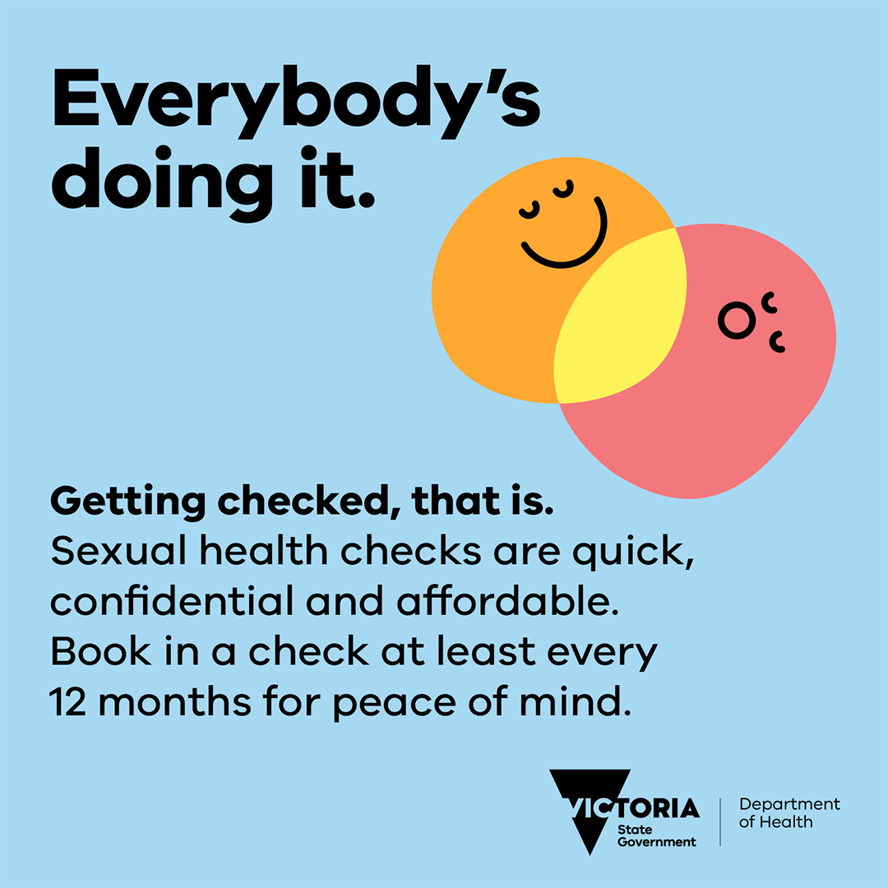
Talk and check before the fun begins!  Getting a sexual health check is easy as. Everybody’s doing it. Book yours today!  Speak to your doctor, nurse or health worker and visit www.betterhealth.vic.gov.au/your-sexual-health to find out more. | X (formerly Twitter) | As above.
Don’t want none unless we’re getting checked, hun!  A sexual health check is the only way to know for sure if you have an STI. All STIs are treatable. Most are curable.  Test regularly, treat early, and stay safe.  Visit www.betterhealth.vic.gov.au/your-sexual-health to find out more. | Facebook and Instagram | 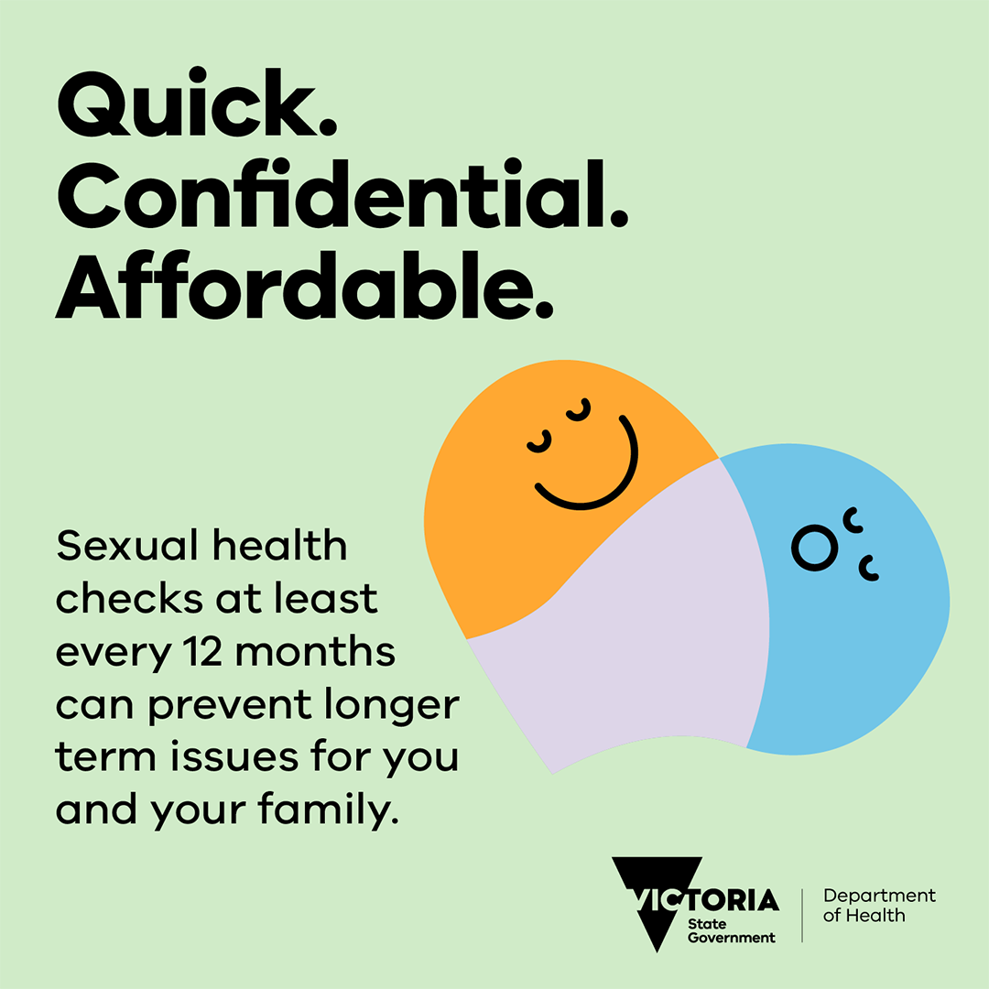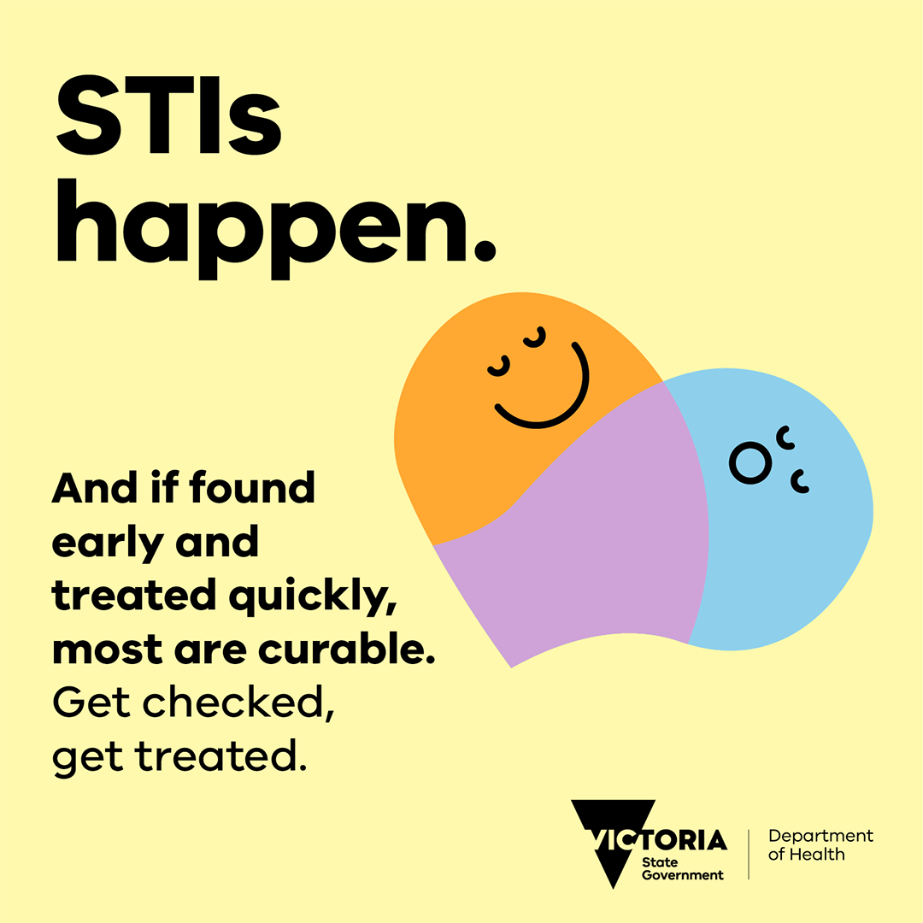
Don’t want none unless we’re getting checked, hun!  A sexual health check is the only way to know for sure if you have an STI.  Test regularly, treat early, and stay safe.  Visit: www.betterhealth.vic.gov.au/your-sexual-health to find out more. | X (formerly) Twitter | As above.
Get the conversation going with your partner(s) about sexual health and pleasure. Use protection to reduce the risk of STIs and unintended pregnancy.  Make the right decisions for you by talking to someone you trust. Speak to your doctor, nurse or health worker and visit www.betterhealth.vic.gov.au/your-sexual-health to find out more. | Facebook and Instagram | 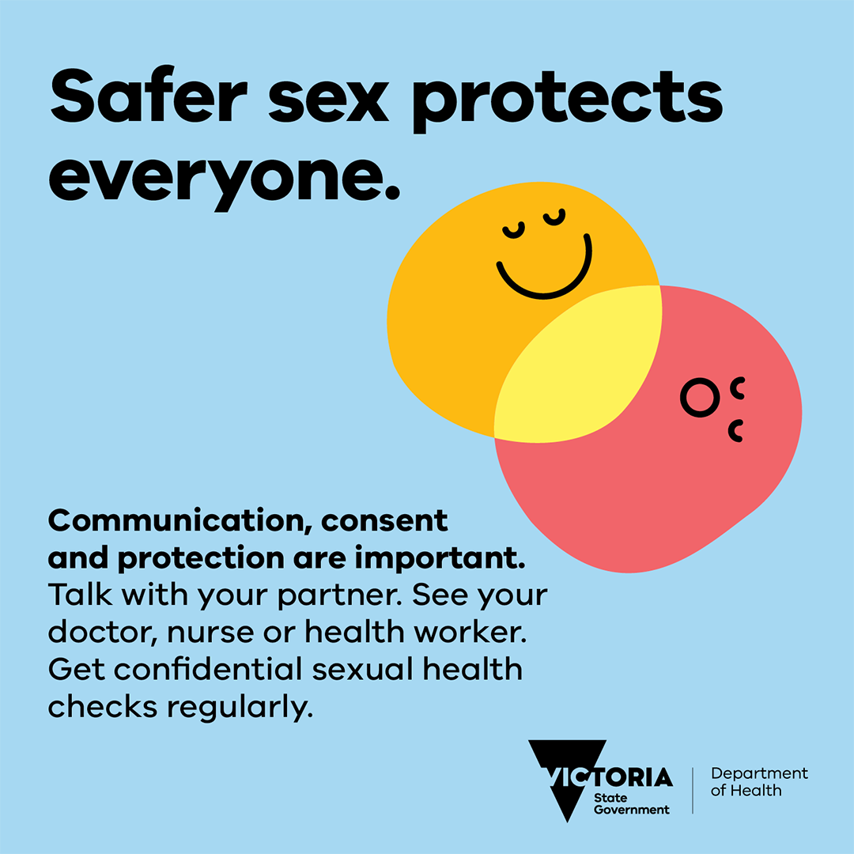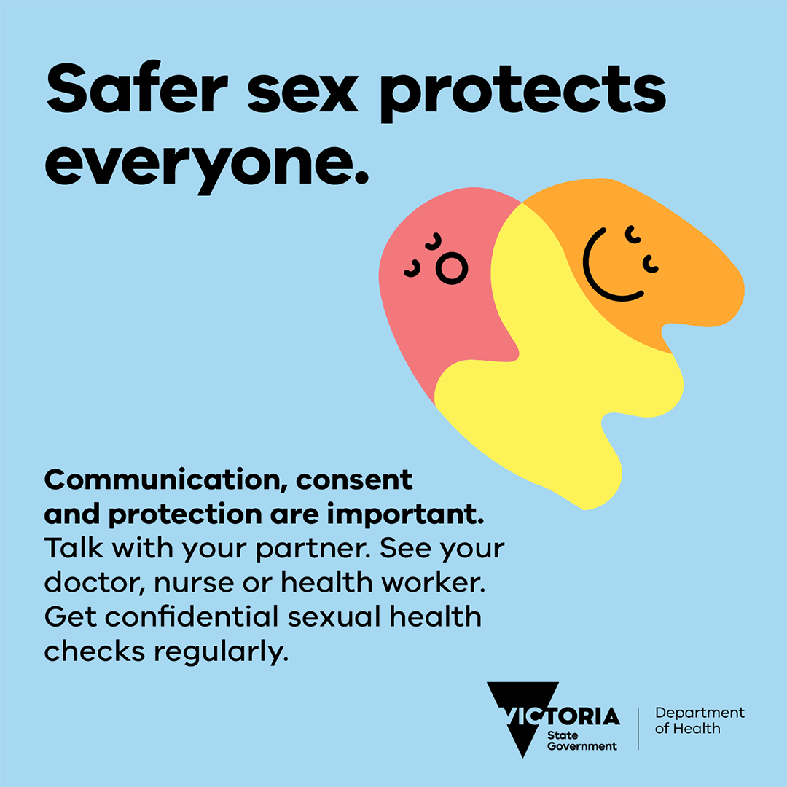
Get the conversation going with your partner(s) about sexual health and pleasure. Use protection to reduce the risk of STIs and unintended pregnancy.  Speak to your doctor or health worker and visit www.betterhealth.vic.gov.au/your-sexual-health to find out more. | X (formerly) Twitter | As above.
STIs are part of life, just like sex. It’s important to get checked and treated so you don’t pass them onto your baby.  If you’re planning a pregnancy, or are already pregnant, put your mind at ease and get a sexual health check for you and your partner(s).  Visit www.betterhealth.vic.gov.au/your-sexual-health to find out more. | Facebook and Instagram | 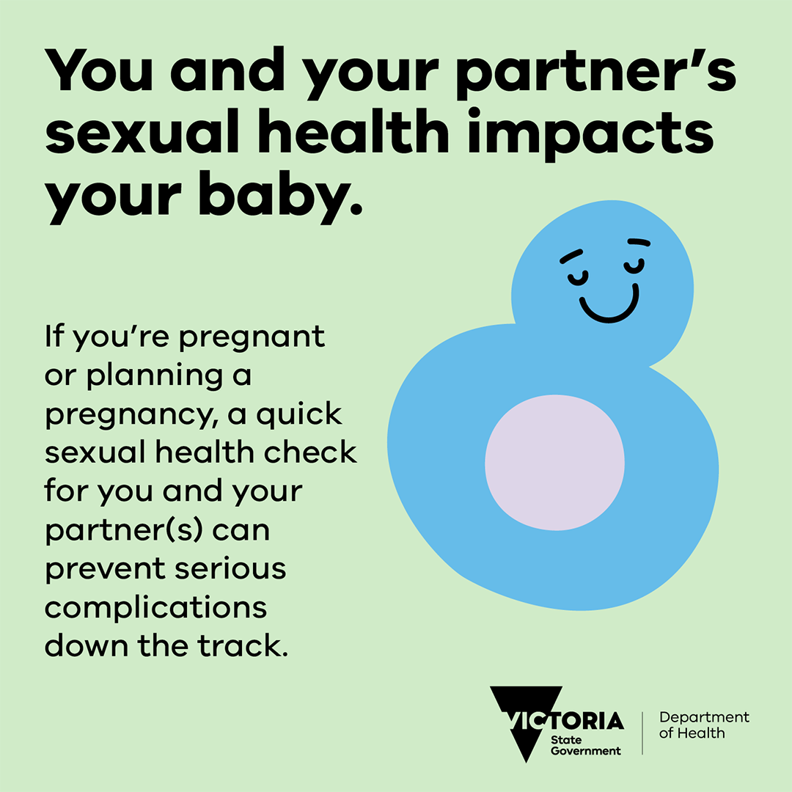
STIs are part of life, just like sex. Get checked and treated so you don’t pass them onto your baby.  If you’re pregnant or planning a pregnancy, get a sexual health check for you and your partner(s).  Visit www.betterhealth.vic.gov.au/your-sexual-health to find out more. | X (formerly Twitter) | As above
Love openly. Talk proudly. Check regularly.  Learning about your sexual health helps you focus on pleasure in the moment.  More info at www.betterhealth.vic.gov.au/your-sexual-health | Facebook and Instagram | 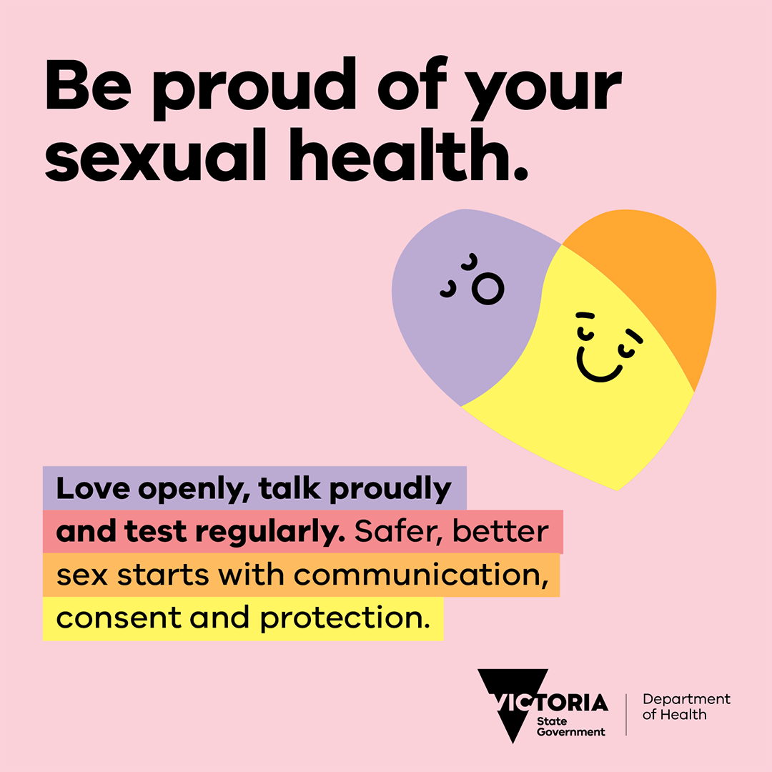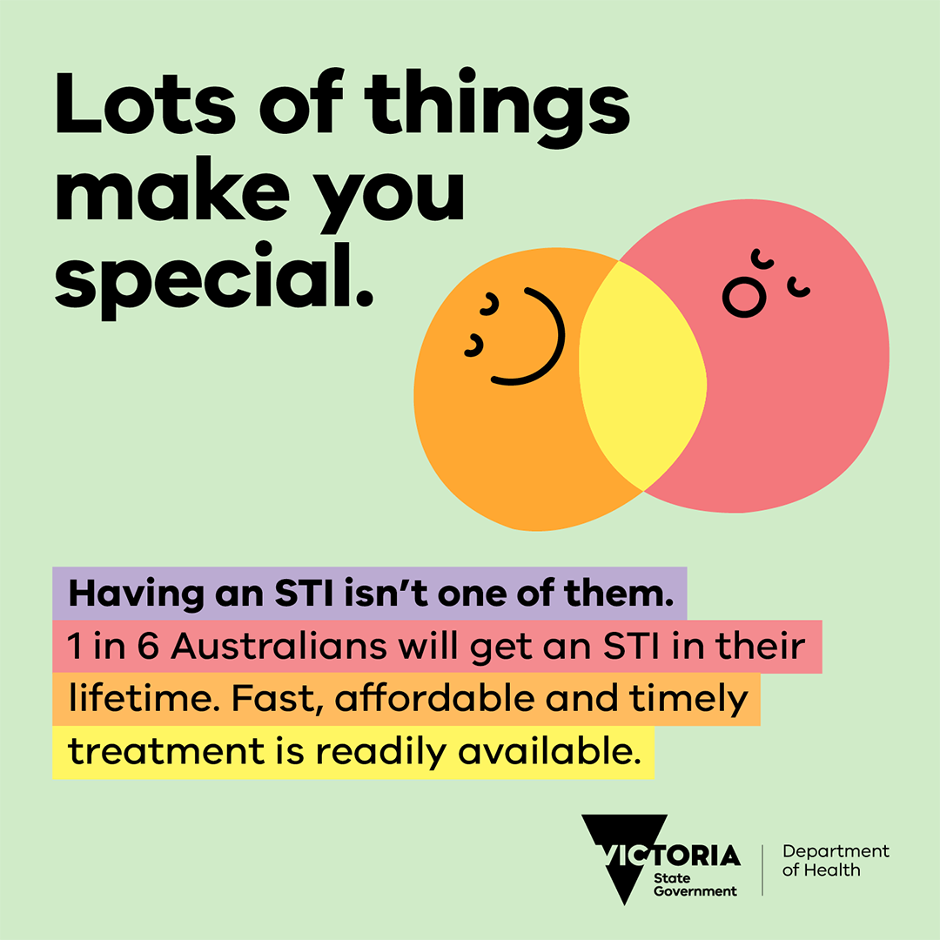
Love openly. Talk proudly. Check regularly.  Learning about your sexual health helps you focus on pleasure in the moment.  More info at www.betterhealth.vic.gov.au/your-sexual-health | X (formerly Twitter) | As above
Let’s talk about sex, baby!  Talking about sexual health shouldn’t be embarrassing.  Talk openly. Stay safe. Get checked. Have fun!  More info at /www.betterhealth.vic.gov.au/your-sexual-health |  | 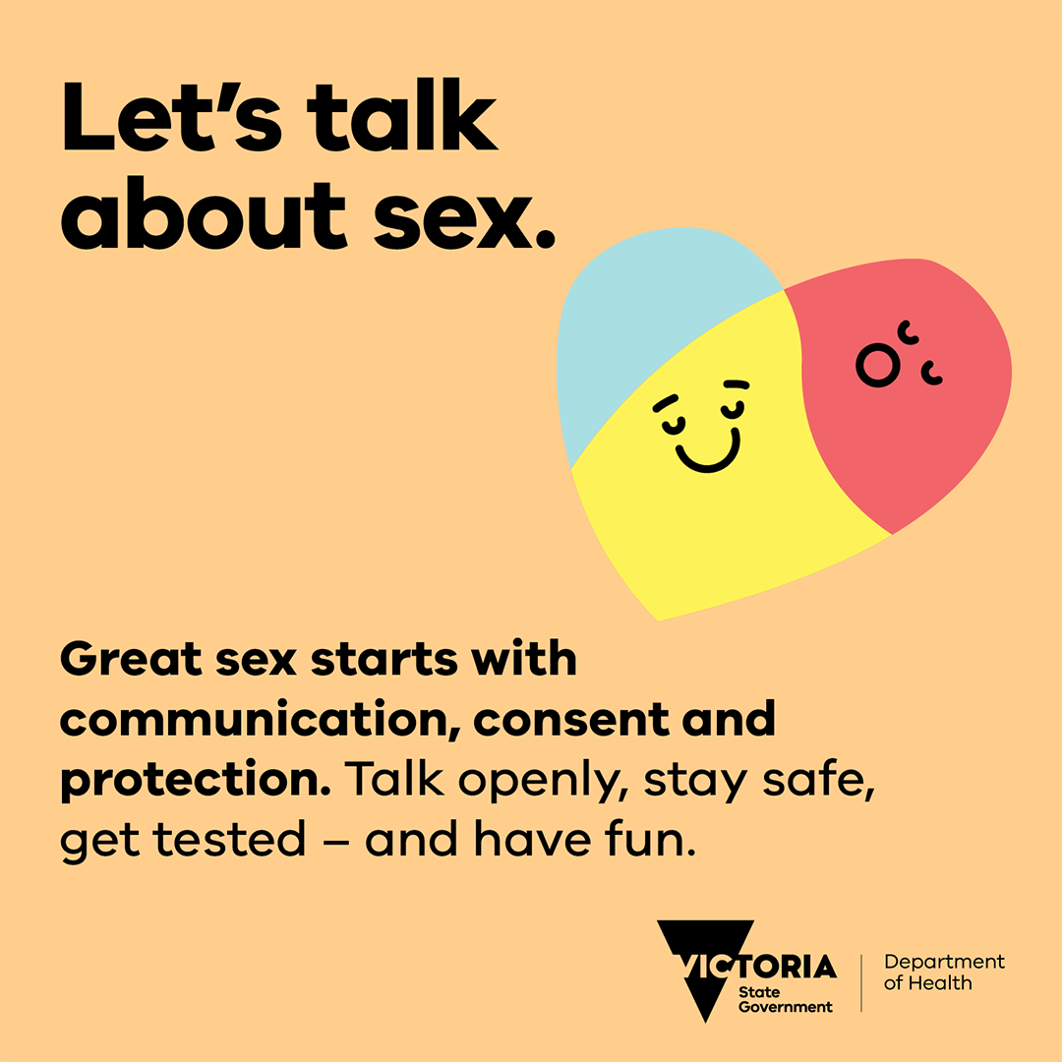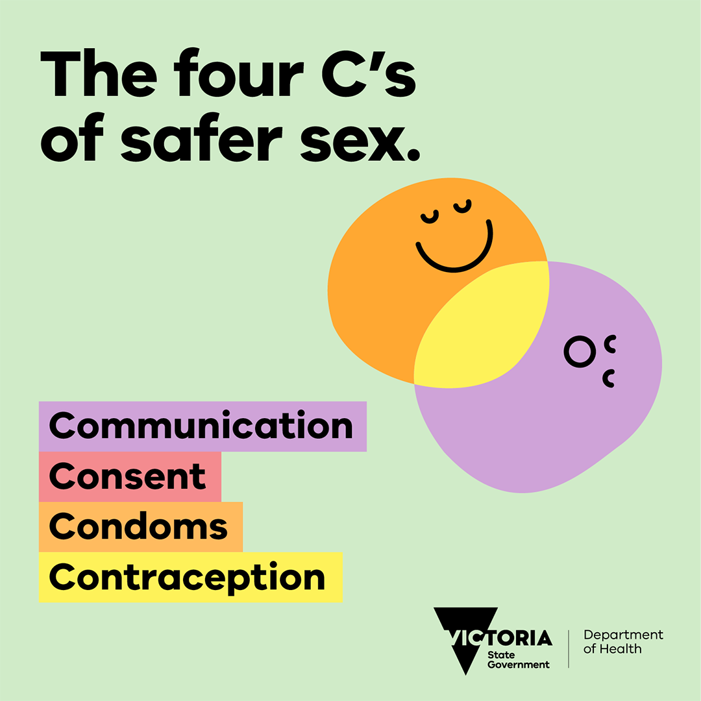
Let’s talk about sex, baby!  Talking about sexual health shouldn’t be embarrassing.  Talk openly. Stay safe. Get checked. Have fun!  More info at www.betterhealth.vic.gov.au/your-sexual-health | X (formerly Twitter) | As above
Syphilis infections are rising in sexually active people. If pregnant, an untreated syphilis infection can cause serious complications for you and your baby.  If you are pregnant, it is important to get tested for syphilis at least three times during your pregnancy: at the first antenatal visit (the first time you see your doctor for health care during pregnancy), at 26-28 weeks and at 36 weeks (or at birth).  Early treatment helps to prevent further complications and to avoid passing the infection on to sexual partners or to an unborn baby during pregnancy.  Visit www.betterhealth.vic.gov.au/your-sexual-health to find out more and talk to your doctor to book a sexual health check today. | Facebook and Instagram | 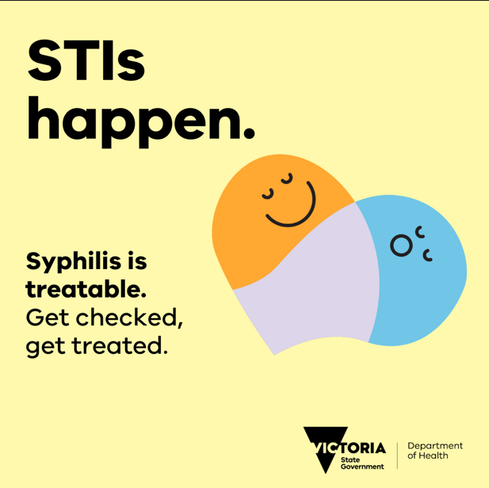
Syphilis infections are rising in sexually active people. If pregnant, an untreated syphilis infection can cause serious complications for you and your baby.  If you are pregnant, it is important to get tested for syphilis at least three times during your pregnancy:  Visit www.betterhealth.vic.gov.au/your-sexual-health to find out more and talk to your doctor to book a sexual health check today. | X (formerly Twitter) | 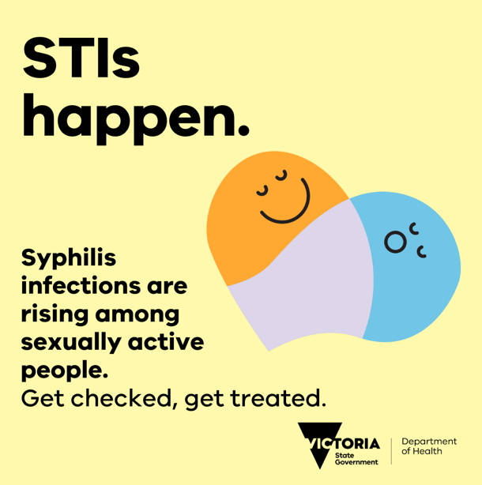
It is important to let your sexual partner (or partners) know that you have syphilis, particularly if they are pregnant or planning to become pregnant.  Talk to your doctor, nurse or health worker and visit https://www.betterhealth.vic.gov.au/your-sexual-health to find out more. | Facebook and Instagram | 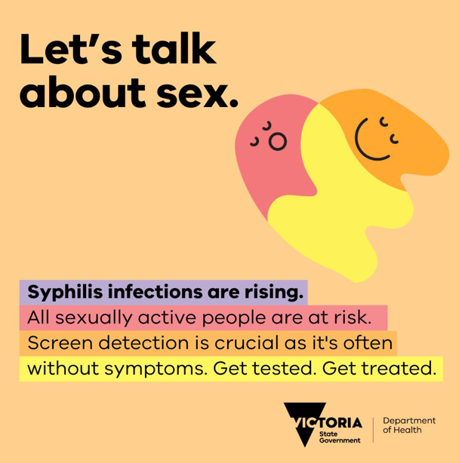
It is important to let your sexual partner (or partners) know that you have syphilis, particularly if they are pregnant or planning to become pregnant.  Talk to your doctor, nurse or health worker and visit https://www.betterhealth.vic.gov.au/your-sexual-health to find out more. | X (formerly Twitter) | As above.

To receive this document in another format, phone 1300 651 160, using the National Relay Service 13 36 77 if required, or email Public Health Communications <pph.communications@health.vic.gov.au>
Authorised and published by the Victorian Government, 1 Treasury Place, Melbourne.
© State of Victoria, Australia, Department of Health, September 2026
Available at Better Health Channel – Your Sexual Health <https://www.betterhealth.vic.gov.au/your-sexual-health>

